Przykładowa lekcja CLIL - BIOLOGIA

Materiał udostępniony przez szkołę partnerską w Hiszpani podczas realizacji projektu.

Karta pracy ucznia

COMPARE AND CONTRAST ANIMAL AND PLANT CELLS
CELL PART | UNDER THE MICROSCOPE | ANIMAL | PLANT
Membrane, cytoplasm and  DNA inside a nucleus | 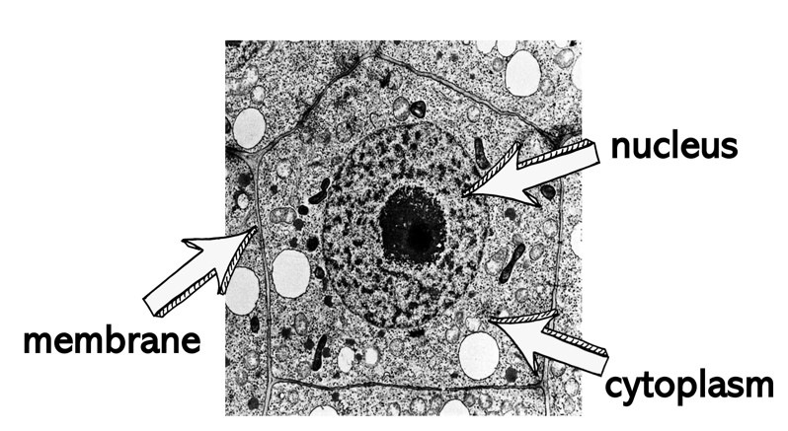
Ribosomes | 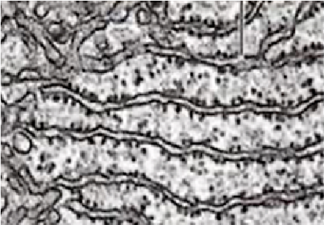
Mitochondria | 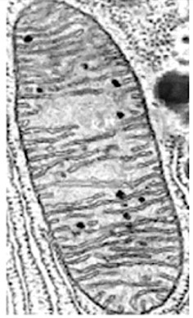
Cell wall | 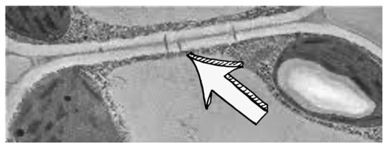
Chloroplasts | 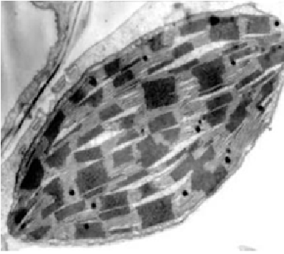
Large central vacuole | 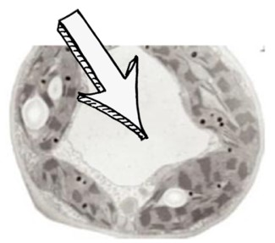

Today you’ll become a Crime Scene Investigator! There has been a robbery in town and you have to find out who did it. However, there is something you have to do first:

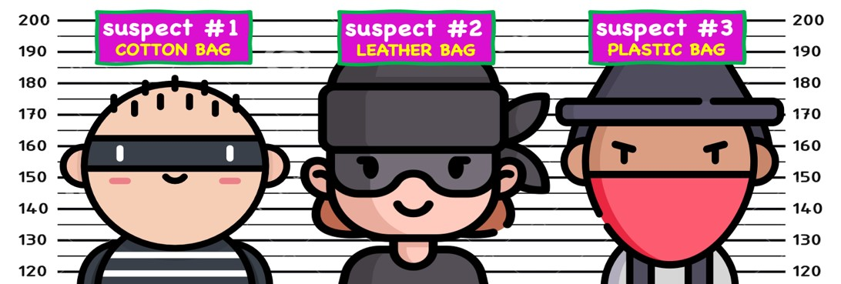

Analyze all the evidence collected by CSI inside the houses A, B and C. Are they animal or plant cells? Play detective and find out which two burglars broke into each house.

- HOUSE A:

# 01: …………………………………………………………………………………………………………………………………………………………………………………………………………………………….
# 02: …………………………………………………………………………………………………………………………………………………………………………………………………………………………….
# 03: …………………………………………………………………………………………………………………………………………………………………………………………………………………………….
# 04: …………………………………………………………………………………………………………………………………………………………………………………………………………………………….
à Suspect ………. and suspect ………. were the ones who broke into house A

- HOUSE B:

# 05: …………………………………………………………………………………………………………………………………………………………………………………………………………………………….
# 06: …………………………………………………………………………………………………………………………………………………………………………………………………………………………….
# 07: …………………………………………………………………………………………………………………………………………………………………………………………………………………………….
# 08: …………………………………………………………………………………………………………………………………………………………………………………………………………………………….
à Suspect ………. and suspect ………. were the ones who broke into house B

- HOUSE C:

# 09: …………………………………………………………………………………………………………………………………………………………………………………………………………………………….
# 10: …………………………………………………………………………………………………………………………………………………………………………………………………………………………….
# 11: …………………………………………………………………………………………………………………………………………………………………………………………………………………………….
# 12: …………………………………………………………………………………………………………………………………………………………………………………………………………………………….
à Suspect ………. and suspect ………. were the ones who broke into house C

